This document is the template for the project description for Innovation Projects for the Public Sector. The project description must follow the setup and instructions provided here. The template has been designed to ensure that all the elements included in the assessment criteria are described. Applicants are encouraged to familiarise themselves with the assessment criteria, which are presented at the end of the text of the call for proposals.

When developing your project we recommend using our project development tool.

The project description is a mandatory attachment to the online grant application form to be completed and submitted via the ‘My RCN Web’ portal. Guidelines are provided for each item in the grant application form, and we recommend that you read these carefully.

The following information is to be entered in the grant application form:
- Project partners
- Information relating to the project
- Relevant thematic areas (the thematic areas are presented in the text of the call. You may select up to three thematic areas of greatest relevance to your application.)
- Progress plan
- Budget

Some of the information entered in the grant application form must be explained in greater detail in the project description. It is therefore recommended that you work with the grant application form and the project description in parallel.

The template provided below must be used, and all items of information must be completed in the given order. Delete the guidelines instructions and (text in italics) and fill in the information for each item in the template.

Main items and sub-items in the template
1. Challenges and needs
2. Excellence
2.1 The innovation
2.1.1 Innovation concept
2.1.2 Knowledge needs
2.2 R&D activities
2.2.1 R&D objectives
2.2.2 R&D challenges, design and scientific methods
3. Impact
3.1 Potential for value creation and usefulness
3.2 Utilisation of results
3.2.1 Plan for the realisation of the innovation
3.2.2 Dissemination, sharing and exploitation
4 Implementation
Project plan for the R&D project
4.1.1 Main activities of the project
4.1.2 Project organisation, cooperation and support

Formal requirements
The project description must not exceed 10 pages, including the list of references, and it is not possible to upload a project description that exceeds this limit. The page format should be A4 with 2 cm margins, single line spacing, and in Arial, Calibri, Times Roman or similar 11-point font. 9-point font may be used for references and figure text. Note that the referees who will be assessing the grant proposal will not be able to open any links entered in the project description.

Project description for Innovation Projects for the Public Sector

Challenges and needs
Describe the challenges and needs the project seeks to resolve.
- Describe how the innovation can help to solve a challenge or meet a need that has been identified by the public sector entity. If there has been a process to define and describe the need/challenge, describe this.

- Explain the relationship between the primary objective and the secondary objectives listed in the grant application form, and how these will address challenges and needs in connection with realising the innovation concept.

Research and innovation
Describe the planned project in a manner that makes it possible to assess the degree to which the project represents an ambitious innovation that is supported by relevant R&D activities.

The innovation

The innovation concept

- Describe the innovation concept of the project and make it clear what kind of innovation(s) it is about:
  - new or changed products/services/systems
  - new or changed methods or processes
  - new or changed forms of management/organisation/working conditions/competence/communication

- Describe how the ideas represent something new for the applicant, any partners in the public sector and, when relevant, other users/target groups as well.

What is innovation?
Innovation in this context means new or significantly improved goods, services, processes, organisation and management forms or concepts that are introduced to achieve value creation and benefits to society.
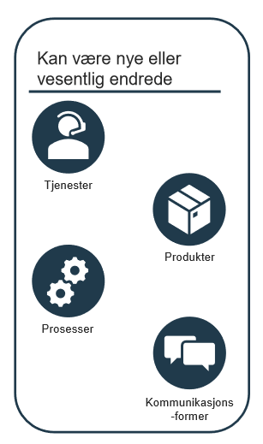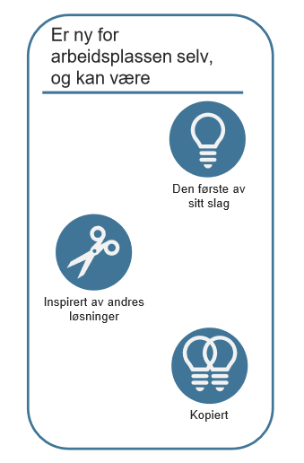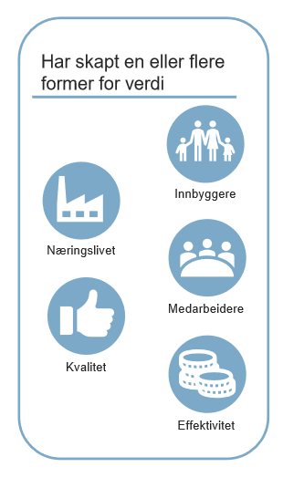
Source: The Norwegian Association of Local and Regional Authorities (KS) Innovation Barometer

Knowledge needs

- Explain why research is necessary to succeed with the innovation, what kind of knowledge exists in the field, and what knowledge needs are not covered by existing research. Feel free to refer to relevant specialist literature (list of literature can be added at the end.

R&D activities

Objectives for R&D activities

    - Provide clearly defined, verifiable objectives for the R&D activities. It must be clearly stated how these are important for realising the innovation idea.R&D challenges, design and scientific methods

- Describe the key R&D challenges involved in the project.

- Describe and delimit the research question that will be addressed. This should be presented in the context of already known or available state-of-the-art knowledge/technology/solutions so as to indicate your knowledge of the research front.

- State whether a search in scientific literature, patent databases or similar has been conducted.

- Explain the the R&D methodology you will use, and why
- What is the level of ambition established for the scientific objectives, and are there any special factors (risks) that may make it difficult to achieve these objectives in full?

3. Impact
Expand on the information you provided in the grant application form under the section on ‘Impact’. Describe how the project will facilitate usefulness and value creation and set up a plan for how the innovation will be introduced and lead to value creation, both during the project and after its conclusion.

Potential for usefulness and value creation
- Describe how the innovation can benefit and create value for the applicant and how the innovation can benefit and create value for others. Which users and actors will benefit from the innovation and what benefit and value will the innovation have for them? For example increased efficiency, improved quality, reduced costs, more useful or improved services for the target groups or other aspects of value creation.

- Describe other positive societal outcomes (e.g. linked to achieving the UN Sustainable Development Goals).

Utilisation of results
Utilisation of results is about reaping benefits and ensuring that both expected and unexpected benefits are actually realised. This means that utilisation of results is about more than just finishing a project; it entails ensuring that practical use is made of the project. Utilisation of results can take place during the project in that some benefits are realised through the implementation of the project itself, and others after the project period is over. Describe a plan for the utilisation of results.

Plan for the realisation of the innovation

- Describe how the innovation will lead to changes and benefits. A draft plan should be submitted for the realisation of the innovation that can be carried out in parallel with the R&D activities in the project (for example utilising results as they are achieved), as well as plans for further realisation after the R&D activities are concluded. Key milestones must be provided for important stages en route to realising benefits. Decision-making points that may be important in determining the course to pursue for realisation of the innovation must be included. You should also consider which tools may be of use and describe roles and support for the project.

- Consider also any risk factors that may have a significant impact on the realisation of the innovation. It may be relevant to consider the following:
  - risks relating to implementation;
  - financing risks;
  - organisational risks;
  - risks relating to the need for amendment of the statutory framework;
  - market risks for any private-sector actors taking part.
Note: Risk factors related to the research activities are to be described in Part 2.2.2.

Examples of relevant factors to describe:
Plan for implementing and introducing new or updated services
Plan for implementing new methods, new organisational structures or new management models.
Plan for introducing new or improved organisational structures or processes.
Methods and tools intended to be used in the utilisation of results.
What measures are planned for the realisation of value creation? Examples include needs for new expertise, new technology, dissemination and training, establishing cooperation to promote better dissemination.
Which resources will be essential to enable the actors to implement the plans for realisation of the innovation?

Various tools may be relevant in this context:
The Norwegian Agency for Public and Financial Management (DFØ)
Roadmap for service innovation from KS
Gevinstrealisering - KS
Knowledge and tools – National Centre for Public Sector Innovation (coi.dk)

Dissemination, sharing and exploitation

- Describe the potential for sharing and dissemination in other segments of the public sector for the benefit of others.
- Describe who will be the target group for sharing and disseminating experience and results.
- Describe activities for dissemination to other parts of the public sector during and after the project has ended.

- Describe the plans for dissemination, both as scholarly and as popular science dissemination.

Implementation
Expand on the information you provided in the grant application form in a manner that makes it possible to assess the degree to which the project plan is realistic.

Project plan for the R&D project
The project plan elaborates on the content of the table "Main activities and milestones in the project period" under "Progress plan" in the application form. Remember that decision points that may involve important path choices in project implementation must be included as milestones in the aforementioned table. Insert a Gantt chart to show the project flow and the relationship between the main activities and milestones.
A main activity must include R&D tasks that either fall under the category "industrial research" or under the category "experimental development", and the categorization must be marked in the table for Progress plan in the application form, in line with the definition set out in the R&D state aid rules.

Budget and funding plan
The costs to be covered and funding to be provided by each partner must be entered in the appropriate tables in the grant application form. Costs per project partner and per main activity are also to be entered in the application form.

Note: Please read the information on the website pertaining to budgets carefully, and consult the guidelines to filling in budget tables in the grant application form.

Main activities of the R&D project

- Describe the overall project plan using a Gantt chart or similar.

- Describe each main activity (M1, M2, etc. in accordance with the table in the application form) providing the following information:
  - Headings of main activities.
  - Scientific content: provide a brief description of what the main activity comprises
  - Deliverables and results
  - Milestones for the R&D activities, note which of these are critical for the implementation of the project. The milestones must be numbered so that it is clear which work package they are connected to.
  - Project partner responsible for carrying out the main activity (use table 2 to summarize which partner is responsible and which partners are involved).
  - Risk management of the research - Complete table 3 to describe research-related risks and plans for handling them.

Table 2: Role distribution (Delete or add lines as needed)
Group and describe partners as follows:
a) Public entities (O1, O2, etc.)
Public entities that have the role of project manager or partner. Describe the entity's role and why they will participate in the project.
b) Research partners (F1, F2, etc.)
Research partners. Describe the role and scientifc justification for the partner's participation in the project. If doctoral or postdoctoral fellows are to be part of the project, describe how their work is relevant to the project's research needs.
c) Other partners (A1, A2, etc.)
Organisations, for example voluntary or interest organisations, companies or others who will be partners in the project. Describe their roles and why they should participate in the project.

Partner  category | Name of partner | Responsible for main acticity: | Participates also in main activity: | Role and justification of participation
O1 |  | (e.g. H1, H2) | (e.g. H3, H4)
F1
A1

Table 3: Risk management of the R&D project (delete or add lines as needed):
Description of risk | Probability | Risk management

Project organisation, cooperation and support

- Describe the project’s organisation and management structure
- Describe how each partner supports the project, which should also be described in the partner form.

- Explain how the selected organisational model and management structure are appropriate in relation to the complexity and size of the project.
- Describe the role that each of the partners will have in the performance of the R&D activities, and the knowledge/expertise that they will be contributing.

If the project entails collaboration with parties other than the partners listed in the table for partners in the application form and table 2 of the project description, these must be described here. This may comprise other national projects/groups, municipalities that will not participate directly in the project, but will monitor it based on an interest in the results, or others. Key information related to subcontractors may also be included here.

5. Bibliography

